3.Vacuum Cleaner Problem
Aim
To simulate a Vacuum Cleaner Agent.
Objective
To clean all dirty rooms.
Algorithm
- Check current location.
- If dirty, clean.
- Move to next room.
- Repeat until all rooms are clean.
Flowchart
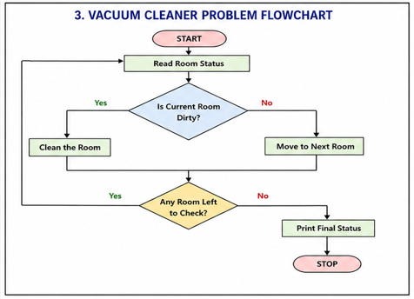
Python code:
rooms = {}

n = int(input("Enter number of rooms: "))

for i in range(n):
room = input("Enter room name: ")
status = input("Enter status (Dirty/Clean): ")
rooms[room] = status

for room in rooms:
if rooms[room] == "Dirty":
print("Cleaning", room)
rooms[room] = "Clean"

print("Final Room Status:", rooms)
output:
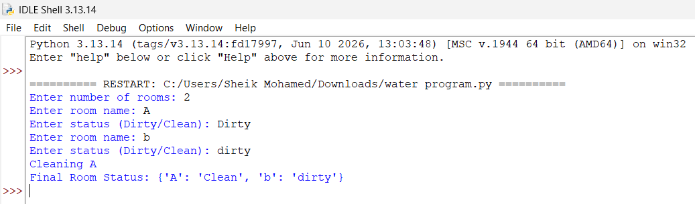
Result
All rooms were cleaned.
Conclusion
The Vacuum Cleaner Agent successfully achieved its goal.

